**ISPIRER TOOL INSTALLATION STEPS**

Link: <http://www.ispirer.com/products/oracle-to-postgresql-migration>

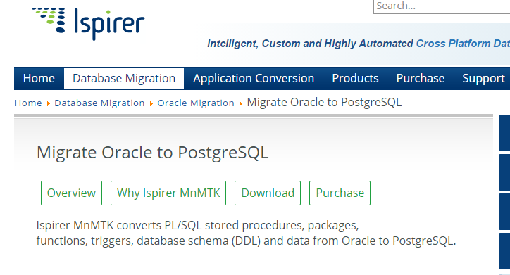

Click On ‘Download’

You will be redirected to this page.

In ‘Try the Toolkit’ portion, Click on ‘Data and SQL’.

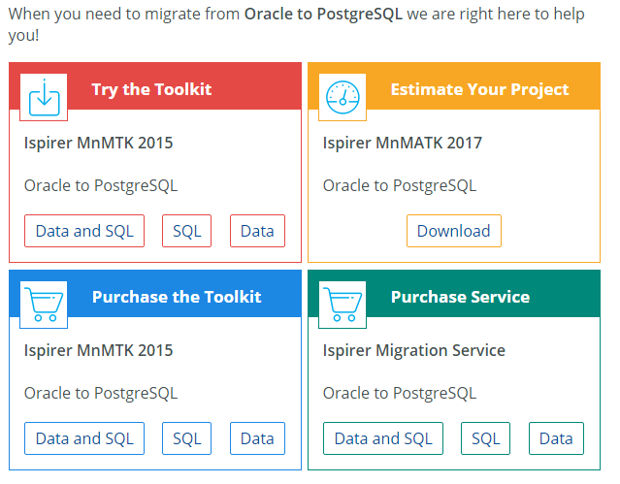

Fill in the required details and click on ‘Send’

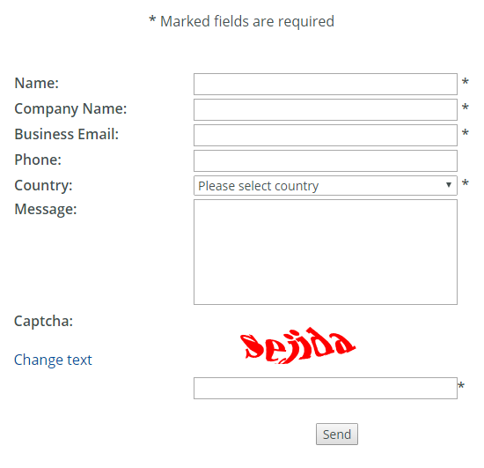

The License Key will be sent to your registered mail.

Download the **License Key.txt** document.

In the Ispirer wizard, enter the License obtained from Ispirer site

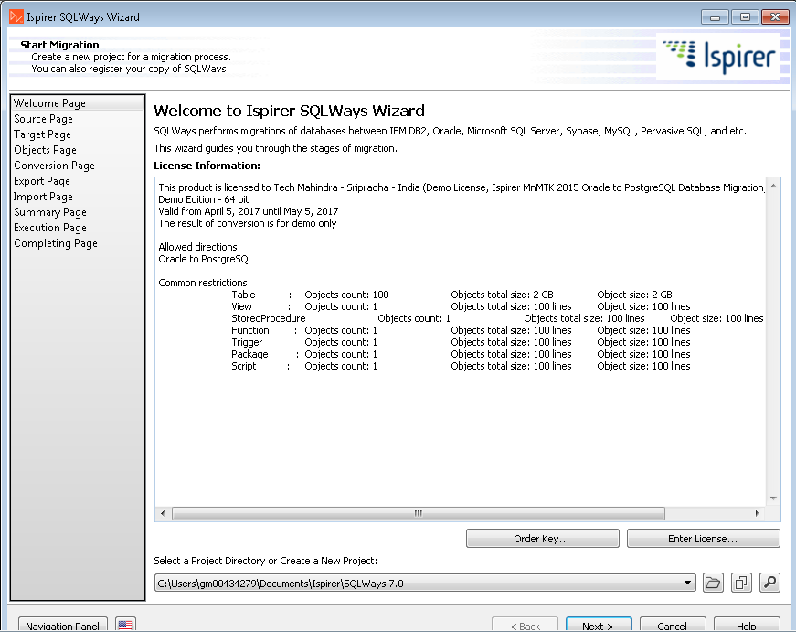

Our example includes migration from oracle(source) to postgresql(target)

Choose the DSN name: Orcl

ODBC Driver: Oracle in OraDb11g_home1

Give User name and password of Oracle : system/EMDLSDB and lsdb/EMDLSDB

Give the Oracle directory in Advanced path

In our case of Oracle to Postgres: E:/app/RR52179/product/11.2.0/dbhome_1

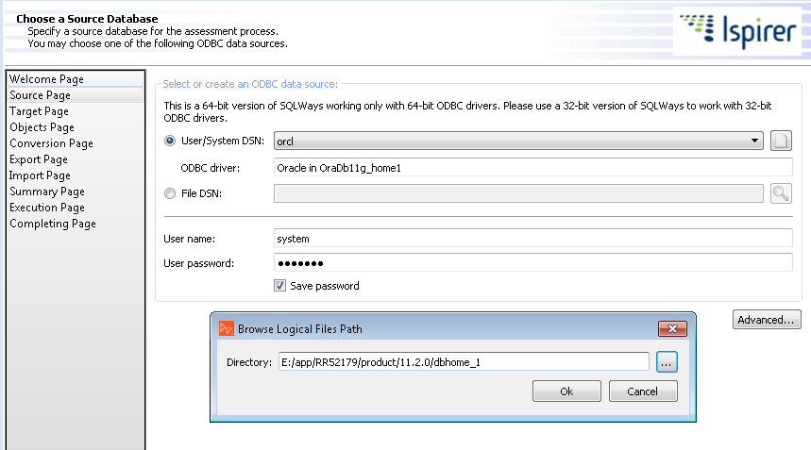

Choose Target Database of the correct version.

Once you enter license the target will be chosen appropriately.

Give the Hostname, Port, Target Database Name, User name and password of target database.

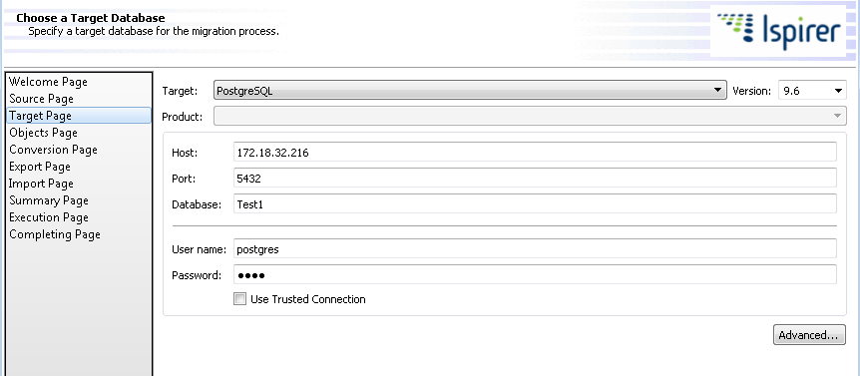

Click on ‘Advanced’ tab of the same page to specify the directory of target database

In this case of Oracle to Postgres: C:\Program Files\PostgreSQL\9.6\bin

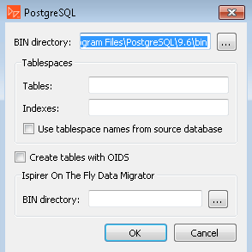

In the next step, specify the data objects to be migrated

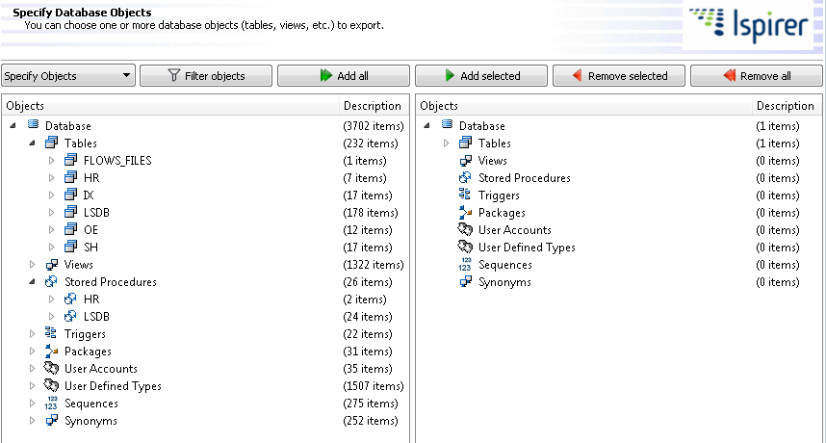

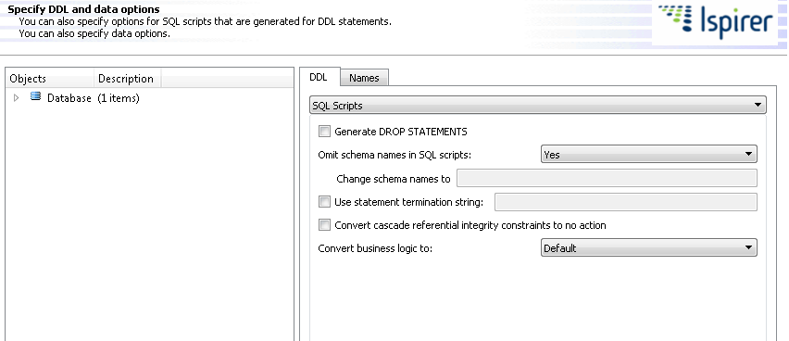

Specify directory for Export files

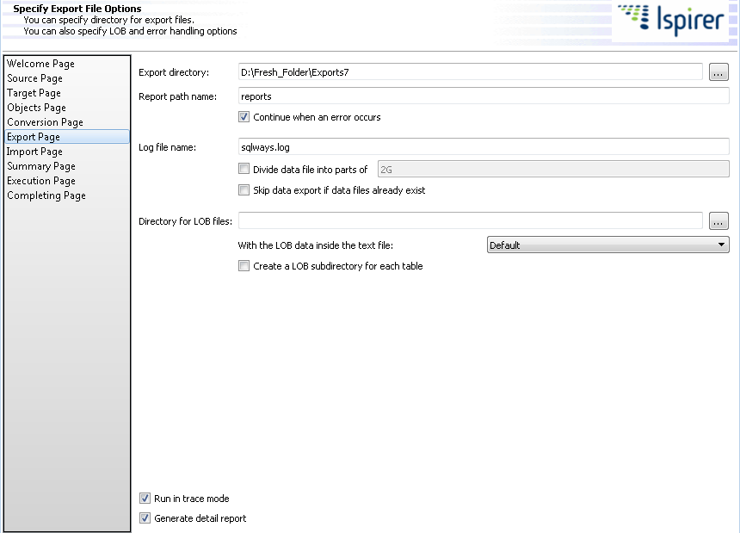

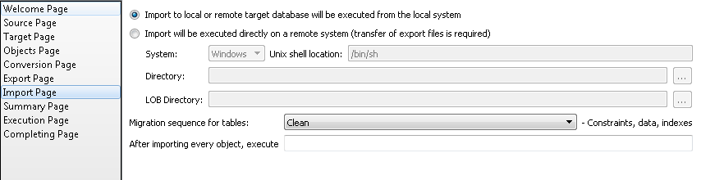

Check the Summary page for exports and imports.

In the Execution page, click on ‘Start Export’ the items selected from the source database.

Check for Errors in parallel.

Once export process is done without errors, Click on ‘Start Import’ to import after migration into the target database.